**Project Report On**

**Library Management**

**System**

**Submitted To***: -* **Submitted By:**

Punjab Technical University

**Doaba Group of Colleges, Mohali**

INDEX

AKNOWLEDGMENT

1. PREACE
2. PROCESS DESCRIPTION
3. INTRODUCTION
4. PROJECT DETAILS
5. SYSTEM DEVELOPMENT LIFE CYCLE
6. SOURCE CODE
7. TESTING
8. ADVANTAGES OF THE SYSTEM
9. FUTURE SCOPE
10. CONCLUSION
11. BIBLIOGRAPHY
12. SNAPSHOTS

# ACKNOWLEDGEMENT

We are extremely grateful and remain indebted to our guidance **Madam Cherry** for being a source of inspiration and for his constant support in the Design, Implementation and Evaluation of the project. We are thankful to them for their constant constructive criticism and invaluable suggestions, which benefited us a lot while developing the project on **“LIBRARY MANAGEMENT”**.

He has been a constant source of inspiration and motivation for hard work. He has been very co-operative throughout this project work. Through this column, it would be our utmost pleasure to express our warm thanks to him for his encouragement, co-operation and consent without which we mightn’t be able to accomplish this project.

We also express our gratitude to **Madam Cherry** for providing us the infrastructure to carry out the project and to all staff members who were directly and indirectly instrument in enabling us to stay committed for the project.

# PREFACE

This project of **“LIBRARY MANAGEMENT”** gives us the complete information about the library. We can enter the record of new books and retrieve the details of books available in the library. We can issue the books to the students and maintain their records and can also check how many books are issued and stock available in the library. In this project we can maintain the late fine of students who returns the issued books after the due date. Throughout the project, the focus has been on presenting information and comments in an easy and intelligible manner. The project is very useful for those who want to know about Library Management System.

In the last, we gratefully acknowledge and express our gratitude to all staff members of BCA Deptt. and friends who supported us in preparing this project.

Basically the project is aimed at developing library management system for the college library. This is intranet based application that can be accessed throughout the campus. This system can be used to search 1000 of books/mega zims, reserve books, find out who is having a particular book put in requests to buy a new book.

This is one integrated system that contains both the user component and the library component. There are features like notifications/reminders, report generators etc in the system.

# PROCESS DESCRIPTION

The Library Management System is designed & developed for a receipt and issuance of books in the library along with the student’s details.

The books received in the library are entered in Books Entry form and the new student is entered in the student entry form.

When the student wants to get the desired book the same is issued on the availability basis to the student. The issuance and due date for the returning of the book is also entered into the Book Issue form under third menu Book Issue.

The student has to pay the fine if any on the basis of no. of days delayed deposit of the book in the library.

# INTRODUCTION TO HTML

HTML (Hypertext Markup Language) is used to create document on the World Wide Web. It is simply a collection of certain key words called ‘Tags’ that are helpful in writing the document to be displayed using a browser on Internet.

It is a platform independent language that can be used on any platform such as Windows, Linux, Macintosh, and so on. To display a document in web it is essential to mark-up the different elements (headings, paragraphs, tables, and so on) of the document with the HTML tags. To view a mark-up document user has to open the document in a browser. A browser understands and interprets the HTML tags, identifies the structure of the document (which part are which) and makes decision about presentation (how the parts look) of the document.

HTML also provides tags to make the document look attractive using graphics, font size and colors. User can make a link to the other document or the different section of the same document by

creating Hypertext Links also known as Hyperlinks.

## OBJECTIVES

After going through this lesson, you would be able to:

* Create, save and view a HTML document
* Format a web page using section heading tags
* Describe Ordered and Unordered lists
* Explain graphics in HTML document
* Describe hypertext links and making text/image links

## CREATING, SAVING AND VIEWING A HTML DOCUMENT

**Creating a HTML document**

The essential tags that are required to create a HTML document are:

<HTML> </HTML>

Starting tag

<HEAD> </HEAD>

<BODY> </BODY>

## HTML Tag <HTML>

The <HTML> tag encloses all other HTML

tags and associated text within your document. It is an optional tag. You

can create an HTML document that omits these tags, and your browser can still read it and display it. But it is always a good form to include the start and stop tags.

## The format is:

### <HTML>

Your Title and Document (contains text with HTML tags) goes here

### </HTML>

Most HTML tags have two parts, an opening tag and closing tag. The closing tag is the same as the opening tag, except for the slash mark e.g. </HTML>. The slash mark is always used in closing tags.

An HTML document has two distinct parts HEAD and BODY.

## The Format is:

<HTML>

<HEA

D>

…………

…………

…………

</HEAD

>

<BODY>

………

…

………

…

………

…

</BODY>

</HTML>

**HEAD Tag <HEAD>**

HEAD tag comes after the HTML start tag. It contains TITLE tag to give the document a title that displays on the browsers title bar at the top.

## The Format is:

### <HEAD>

<TITLE>

Your title goes here

</TITLE>

</HEAD>

## BODY Tag <BODY>

The BODY tag contains all the text and graphics of the document with all the HTML tags that are used for control and formatting of the page.

## The Format is:

### <BODY>

Your Document goes here

### </BODY>

An HTML document, web page can be created using a text editor, Notepad or WordPad. All the HTML documents should have the extension .htm or .html. It require a web browser like Internet Explorer or Netscape Navigator/Communicator to view the document.

**Example**: It is my first web page

## Follow the steps to create and view in browser:

Step-1: Open text editor Notepad (click on Start Programs Accessories Notepad

Step-2: Enter the following lines of code

<HTML>

<HEAD>

<TITLE>

My first Page

</TITLE>

</HEAD>

<BODY>

WELCOME TO MY FIRST WEB PAGE

</BODY>

</HTML>

Step-3: Save the file as myfirstpage.html (go to File-Save As- give File name: myfirstpage.html-choose save as type All Files-click save)

Step-4: Viewing document in web browser (open Internet Explorer-click

on File-Open-Browse-select the file myfirstpage.html-click open-click ok)

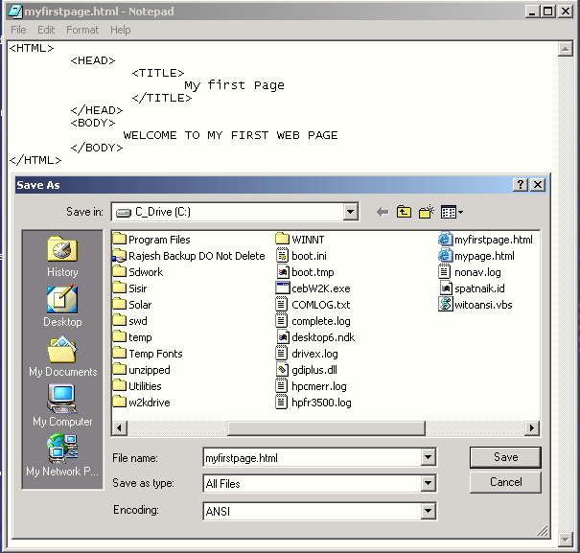

Fig:- Viewing HTML documentMyfirstpage.html in browser

## Attributes used with <BODY>

BGCOLOR: used to set the background color for the

document.

## Example:

<BODY BGCOLOR="yellow">

Your document text goes here

### </BODY>

**TEXT**: used to set the color of the text of the document

## Example:

<BODY TEXT="red">

Document text changed to red color

### </BODY>

**MARGINS**: set the left hand/right hand margin of the document.

**LEFTMARGIN**: set the left hand margin of the document.

## Example:

### <BODY LEFTMARGIN="60">

This document is indented 60 pixels from the left hand side of the page.

### </BODY>

**TOPMARGIN:** set the left hand margin of the document.

## Example:

### <BODY TOPMARGIN="60">

This document is indented 60 pixels from the top of the page.

### </BODY>

**BACKGROUND**: It is used to point to an image file (the files with an extension .gif, .jpeg) that will be used as the background of the document. The image file will be tiled across the document.

## Example:

<BODY BACKGROUND="filename.gif"> Your document text goes here

### </BODY>

**Example:** An HTML document attribute.html that shows the use of attributes with the <BODY> tag

<HTML>

<HEAD>

<TITLE>

Use of Attributes with the Body Tag

</TITLE>

</HEAD>

<BODYBACKGROUND="computer.gif" text="blue"

TOPMARGIN ="75" LEFTMARGIN="75"

Your document text will be indented 75 pixels from the left hand and 75 pixels from the top of the page. The background image computer.gif will be tiled across the document. Your image and HMTL document should present at the same place.

</BODY>

</HTML>

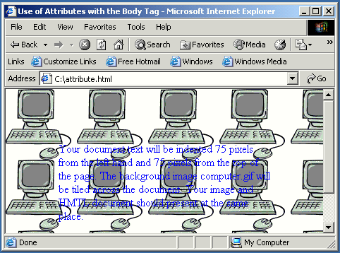

Fig.:- Viewing HTML document attribute.html in browser

# Container and Empty Tags:-

All HTML tags are enclosed in angle brackets ‘<’ and ‘>’ i.e. Opening Tag: <HTML> and closing tag: </HTML> same as opening tag except a / (slash) mark. Tags are not case-sensitive i.e. there is no difference in small and capital letters in tags.

# There are two types of tags:

1. **Container Tags**:

Tags which have both the opening and closing i.e.

<TAG> and </TAG> are called container tags They hold the text and other HTML tags in between the tags. The <HTML>,

<HEAD>, <TITLE> and <BODY> tags are all container tags.

Example:

<TAG> this is a container tag. It holds both the text and HTML

tag </TAG>

1. **Empty Tags:**

Tags, which have only opening and no ending are

called empty tags. The <HR>, which is used to draw Horizontal, rule across the width of the document, and line break <BR> tags are empty tags.

## FORMATTING WEB PAGE:

**HTML tags used for formatting a web page are:**

### SECTION HEADING: <H1> <H6>

HTML has six header tags <H1>, <H2>...........<H6> used to specify section headings. Text with header tags is displayed in larger and bolder fonts than the normal body text by a web browser. Every header leaves a blank line above and below it when displayed in browser.

**Example:** An HTML document, headings.html shows the different section headings.

<HTML>

<HEAD>

<TITLE>

Section Heading

</TITLE>

</HEAD>

<BODY>

<H1> This is Section Heading 1 </H1>

<H2> This is Section Heading 2 </H2>

<H3> This is Section Heading 3 </H3>

<H4> This is Section Heading 4 </H4>

<H5> This is Section Heading 5 </H5>

<H6> This is Section Heading 6 </H6>

</BODY>

</HTML>

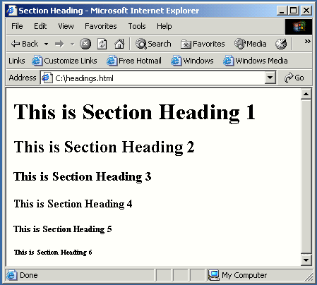

Fig. 4.4 : Viewing HTML document headings.html in browser

## Some peculiarities about the web browser on viewing HTML document text:-

* Browsers ignore extra space within HTML document

Browsers ignore any additional space you type, and compress the text as if the space did not exist. For Example: You can have text "My First Page".

* Browsers ignore your extra line and paragraph breaks

Generally you press enter when you want to create line and paragraph breaks, but they won’t show up when you view the document in browser.

## In order to control your paragraph and line breaks, <P> and <BR> tags are used

**Using paragraph tag: <P>**

This tag <P> indicates a paragraph, used to separate two paragraphs with a blank line.

## Example:

<P> Welcome to the world of HTML </P>

<P> First paragraph.

Text of First paragraph goes here </P>

## Output:

Welcome to the world of HTML

First paragraph. Text of First paragraph goes here

Here, two paragraphs are separated with a line. But web browser ignores the line breaks in the second paragraph that can be controlled by putting

<BR> tag.

Using Line Break Tag: <BR>

The empty tag <BR> is used, where the text needs to start from a new line and not continue on the same line. To get every sentence on a new line, it is necessary to use a line break.

## Example:

### <BODY>

National Institute of Open Schooling <BR>

B-31B, Kailash Colony <BR> New Delhi-110048

</BODY>

## Output:

National Institute of Open Schooling B-31B, Kailash Colony

New Delhi-110048

## Using Preformatted Text Tag: <PRE>

<PRE> tag can be used, where it requires total control over spacing and line breaks such as typing a poem. Browser preserves your space and line break in the text written inside the tag.

Example:

### <PRE>

</PRE>

National Institute of Open Schooling B-31B, Kailash Colony

New Delhi-110048

## Output:

National Institute of Open Schooling B-31B, Kailash Colony

New Delhi-110048

**Example**: An HTML document control.html shows the use of <P>,

<BR> and <PRE>

<HTML>

<HEAD>

<TITLE>

Use of Paragraph, Line break and preformatted text Tag

</TITLE>

</HEAD>

<BODY>

HTML Tutorial

<P>

HTML stands for Hypertext Markup Language It is used for creating web page. It is very simple and easy to learn.

</P

<P>

HTML stands for Hypertext Markup Language.<BR> It is used for creating web page. It is very simple<BR> and easy to learn.<BR>

</P>

<PRE>

HTML stands for Hypertext Markup Language It is used for creating web page. It is very simple and easy to learn.

</PRE>

</BODY>

</HTML>

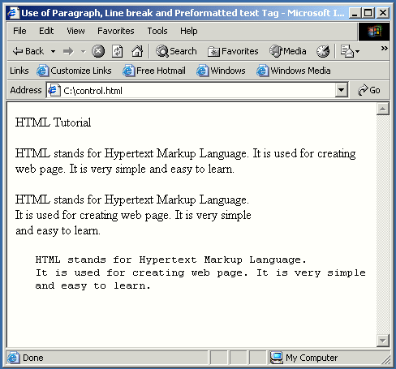

Using Horizontal Rule Tag: <HR>

An empty tag <HR> basically used to draw lines and horizontal rules. It can be used to separate two sections of text.

## Example:

### <BODY>

Your horizontal rule goes here. <HR> The rest of the text goes here

</BODY>

## Output:

Your horizontal rule goes here The rest of the text goes here

## <HR> accepts following attributes:

**SIZE:** Determines the thickness of the horizontal rule. The value is given as a pixel value.

**Example:** <HR SIZE="3">

**WIDTH**: Specifies an exact width of HR in pixels, or a relative width as percentage of the document width.

**Example:** <HR WIDTH="50%">, horizontal rule a width a 50 percent of the page width.

**ALIGN:** Set the alignment of the rule to LEFT, RIGHT and CENTER. It is applicable if it is not equal to width of the page.

**NOSHADE**: If a solid bar is required, this attribute is used; it specifies that the horizontal rule should not be shaded at all.

**COLOR:** Set the color of the Horizontal rule

**Example:** <HR COLOR="BLUE">

## Example of <HR> with its attribute:

<HR ALIGN=''CENTER'' WIDTH=''50%'' SIZE=''3" NOSHADE COLOR="BLUE">

## Character Formatting Tags:

The character formatting tags are used to specify how a particular text should be displayed on the screen to distinguish certain characters within the document.

**The most common character formatting tags are: Boldface <B>:** displays text in BOLD

**Example:** Welcome to the <B> Internet World </B>

**Output:** Welcome to the Internet World

**Italics <I>** : displays text in Italic

**Example**: Welcome to the <I> Internet World </I> **Output**: Welcome to the Internet World **Subscript <SUB>** : displays text in Subscript

**Superscript <SUP>:** displays text in Superscript

**Small <SMALL>:** displays text in smaller font as compared to normal font

**Big <BIG>** :displays text in larger font as compared to normal font.

## Font Colors and Size:<FONT>

By using <FONT> Tag one can specify the colors, size of the text.

**Example**: <FONT> Your text goes here </FONT>

## Attributes of <FONT> are:

**COLOR:** Sets the color of the text that will appear on the screen. It can be set by giving the value as #rr0000 for red (in RGB hexadecimal format), or by name.

**Example**: <FONT COLOR="RED"> Your text goes here </ FONT>

SIZE: Sets the size of the text, takes value between 1 and 7, default is 3. Size can also be set relative to default size for example; SIZE=+X, where X is any integer value and it will add with the default size.

**Example:** <FONT SIZE=5> Font Size changes to 5 </FONT>

<FONT SIZE=+2> Font Size changes to 5 i.e. default size (3)

### ±2</FONT>

**FACE:** Sets the normal font type, provided it is installed on the user’s machine.

**Example:** An HTML document formatText.html shows the use of Character Formatting Tags.

<HTML>

<HEAD>

<TITLE>

Use of Character Formatting Text Tags

</TITLE>

</HEAD>

<BODY>

<H1><I> Welcome to the world of Internet</I></H1> It is a

### <FONT COLOR="BLUE" SIZE="4">

<U>Network of Networks</U>

</FONT>

</BODY>

</HTML>

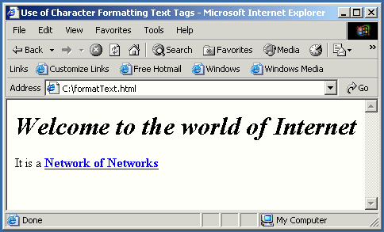

Fig.:- Viewing HTML document formatText.html in browser

## Using Some Special Characters

There are certain special characters that can be used while creating document.

Following are some special character:

|  |  |
| --- | --- |
| **Symbols** | **Entity** |
| ©, ® | &copy, &reg |
| ¼, ½, ¾ | &frac14, &frac12, &frac34 |
| ÷, <, >, , | &divide, &lt, &gt, &le, &ge |
| & | &amp |

|  |  |
| --- | --- |
| ▪ | &spades, &clubs, &hearts |

All these special character must be ended with a semicolon;

**Example:** <PRE>

### </PRE>

The copyright symbol is: &COPY The registered rank is: &REG;

**Output:** The copyright symbol is:© The registered rank is:®

## USING LIST IN WEB PAGE

HTML Supports several ways of arranging items in lists. The most commonly used are:

* Ordered List (Numbered List)
* Unordered List (Bulleted List)

## Ordered List <OL>

Ordered list also called as Numbered list, is used to present a numbered list of item in the order of importance or the item (paragraph) is marked with a number.

An ordered list must begin with the <OL> followed by an <LI> list item tag.

**Example:** An HTML document orderedList.html shows the use of Ordered List

<HTML>

<HEAD>

<TITLE>

An Ordered List

</TITLE>

</HEAD>

<BODY>

<H1><U> Various Terms Used In Internet</U></H1>

### < OL>

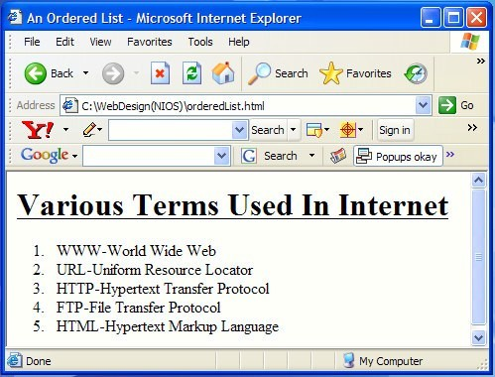<LI> WWW-World Wide Web

<LI> URL-Uniform Resource Locator

<LI> HTTP-Hypertext Transfer Protocol

<LI> FTP-File Transfer Protocol

<LI> HTML-Hypertext Markup Language

</OL>

</BODY>

</HTML>

32

Fig.:- Viewing HTML document orderedList.html in browser

## Attributes of <OL> tag:

* + **COMPACT**: render a list in compact form
  + **TYPE**: allows marking list items with different types. By default the list Item markers are set to numbers 1,2,3… so on.

## Other values of TYPE attribute are:

|  |  |
| --- | --- |
| Attribute | Description |
| Type = A | Capital letter eg. A, B, C……… |
| Type = a | Small letter eg. a, b, c,……… |

|  |  |
| --- | --- |
| Type = I | Uppercase Roman Numbers eg. I, II, III…… |
| Type = i | Lowercase Roman Numbers eg. i, ii, iii…… |
| Type = 1 | eg. 1, 2, 3…………. |

* + **START:** used for lists that need to start at values other than 1. START always specified in default numbers, and is completed based on TYPE before display, For example, If START =5 it would display either an ‘E’, ‘e’, ‘V’, ‘v’, or ‘5’

based an TYPE attribute.

## Nested Order List

One ordered list might contain one or more ordered list that is called as Nested Order lists.

**Example**: An HTML document nested.html shows the use of Nested Order Lists with attributes.

<HTML>

<HEAD>

<TITLE> Use of Nested Ordered

Lists</TITLE>

</HEAD>

<BODY>

<OL TYPE = A START =3>

<LI> Fruits

<OL TYPE = I>

<LI> Apple

<LI> MANGO

<LI> Orange

</OL>

<LI> VEGETABLES

<OL TYPE = I>

<LI> Brinjal

<LI> Cabbage

<LI> Tomato

</OL>

</OL>

</BODY>

</HTML>

Fig.: -Displaying Nested Ordered Lists with attributes in browser

## Unordered List <UL>

Unordered List also called as bulleted list, used to present list of items marked with bullets. An unordered list starts with in <UL> followed by

<LI> (List Item) tag. Use of <UL> is very similar to <OL> (ordered list).

**Example**: Use of Unordered List and Various Attributes

<HTML>

<HEAD>

<TITLE> Use of Unordered List </TITLE>

</HEAD>

<BODY>

<UL>

<LI> FRUITS

<UL>

<LI> Apple

<LI> Mango

<LI> Orange

</UL>

<LI> VEGETABLE

<UL>

<LI> Brinjal

<LI> Cabbage

<LI> Tomato

</UL>

</UL>

</BODY>

</HTML>

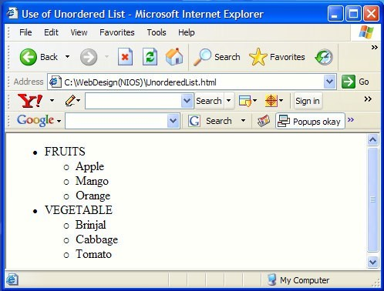

## USING GRAPHICS IN WEB PAGE <IMG>

Images can be placed in a web page by using <IMG> tag. There are many image formats available today, but the most widely used among them are gif and jpeg. The gif format is considered superior to the jpeg format for its clarity and ability to maintain the originality of an image without lowering its quality. Using tools such as GIF constructor or Adobe Photoshop images can be created.

**It is an empty tag** (only start tag, no end tag) and is written as:

## <IMG SRC = image_URL> SRC – Source of the image file

**image_URL** – represents the image file with its location.

**Example:** <IMG SRC=file:///C:/NOSlogo.GIF>

Here, image_URL =file:///C:/NOSlogo.GIF, it means image is available in the Hard Drive C: on the local hard disk.

**Example:** <IMG SRC =<http://planningcommission.nic.in/> images/planimg.jpg>

**Here image _URL is** = <http://planningcommission.nic.in/images> planimg.jpg. The image planimg.jpg, is taken from the images directory of Planning Commission Web Server ‘Planningcomm- ission.nic.in’.

If the location of the image and web page are in the same place in the same directory/path then it is simply written <IMG SRC=NOSlogo.GIF>

## This SRC attribute is mandatory for the <IMG> tag Other attributes used with <IMG> are: -

### ALIGN

* + HEIGHT AND WIDTH
  + VSPACE and HSPACE

### ALT

* + BORDER

**ALIGN:** used to set the alignment of the text adjacent to the image. It takes the following values:

* + ALIGN = LEFT - Displays image on left side and the subsequent

text flows around the right hand side of that image

* + ALIGN = RIGHT - Displays the image on the right side and the subsequent text flows around the left hand side of that image.
  + ALIGN = TOP - Aligns the text with the top of the image
  + ALIGN = MIDDLE - Aligns the text with the middle of the image.
  + ALIGN=BOTTOM - Aligns the text with the bottom of the image.

**By default, the text is aligned with the bottom of the image Example:** Using <IMG> tag with attributes

<HTML>

<HEAD>

<TITLE> Use of IMG Tag With its ALIGN Attribute</TITLE>

</HEAD>

<BODY>

<P>

<IMG SRC=NOSlogo.GIF ALIGN=TOP>

Aligns the text with the Top of the image

</P>

<P>

<IMG SRC=NOSlogo.GIF ALIGN=MIDDLE>

Aligns the text with the Middle of the image

</P>

<p>

<IMG SRC=NOSlogo.GIF ALIGN=LEFT>

Displays image on left side and the subsequent text flows around the right hand side of that image. Displays image on left side and the subsequent text flows around the right hand side of that image. Displays image on left side and the subsequent text flows around the right hand side of that image.

### </P>

<P>

<IMG SRC=NOSlogo.GIF ALIGN=RIGHT>

Displays image on right side and the subsequent text flows

around the left hand side of that image. Displays image on right side and the subsequent text flows around the left

hand side of that image.

</P>

</BODY>

</HTML>

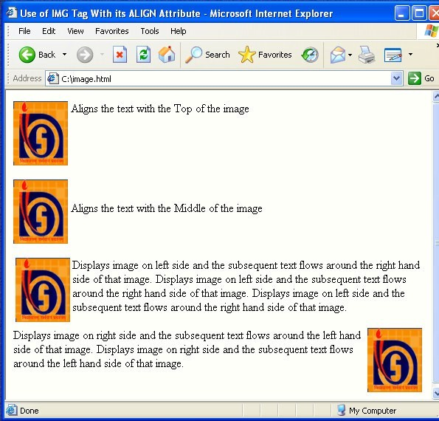

Fig.:- Displaying Image with its attributes in browser

## HEIGHT and WIDTH

Height and Width of an image can be controlled by using the HEIGHT and WIDTH attributes in the <IMG> tag as follows:

**Example:** <IMG SRC= NOSlogo.GIF HEIGHT=320 WIDTH=240>

## HSPACE and VSPACE

White space around an image can be provided by using HSPACE (Horizontal Space) and VSPACE (Vertical Space) attributes of the

<IMG> tag. These attributes provide the space in pixels.

**Example**: <IMG SRC=NOSlogo.GIF VSPACE=30 HSPACE=25>

## ALT (Alternative Text)

This attribute is used to give alternative text that can be displayed in place of the image. This is required when the user needs to stop display of images while retrieving a document in order to make the retrieval faster, or when the browser does not support graphics. It is also used a tool tips – displaying description of the image when the mouse is over the image.

**Example:** <IMG SRC=NOSlogo.GIF ALT = "NOSLogo">

## BORDER

Border around the image can be controlled by using BORDER attribute of <IMG> tag. By default image displays with a thin border. To change the thickness or turn the border off, the value in pixels should set to BORDER attribute.

**Example:** <IMG SRC=NOSlogo.GIF BORDER=0>

BORDER =0 to Turn the Border off

**Example:** <IMG SRC=NOSlogo.GIF BORDER=3>

BORDER=3 to make the border thickness to 3

**Example**: Showing the use of Image Attributes

<HTML>

<HEAD>

<TITLE> Use of Image Attributes

</TITLE>

</HEAD>

<BODY>

<IMG SRC=NOSLogo.GIF HSPACE=5 VSPACE=5 BORDER=5 ALT=NOS LOGO ALIGN=LEFT>

National Institute of Open Schooling. National Institute of Open Schooling.

National Institute of Open Schooling. National Institute of Open Schooling.

National Institute of Open Schooling. National Institute of Open Schooling

</BODY>

</HTML>

Fig : Displaying Image with its attributes in browser

## Understanding Image Maps

Image Maps as, the name suggests, means mapping/linking to different URL’s different portion of one image. Clicking on a portion of an image, one can jump to the link connected with that part.

**For example:** Different areas in the map of India may be linked to the URL of website of the respective states.

Position of an image that acts as a link to different URL can be of

different shapes and sizes depending on one choice. Possible shapes are circle, oval, rectangle, polygon and point. Image maps are widely used in Web pages. They are mainly used with geographic maps, organization charts, drawing of multi component structures and so on. Best view in the site: [http://planningcommission.nic.in.](http://planningcommission.nic.in/) An image map can be created by using Image Mapping Software MapThis. The software can be freely downloadable from[http://www.freedownloadscenter.com](http://www.freedownloadscenter.com/)Web_Authoring/Image_Mappi ng_Tools/MapThis.html.

## WORKING WITH LINKS: <A> ANCHOR TAG

Web pages are linked to one another through Hypertext Links. Section of text or image in the HTML document can be linked to an external document or to a specific place within the same document. The text or image that provides such linkage is known as Hypertext or Hotspot

HTML provides <A> Anchor Tag to create links. The format of using anchor tag is as follows:

<A HREF ="URL"> Make Me The Link </A>

HREF (Hyper Link Reference) is a mandatory attribute used to refer the URL of the resource. URL (Uniform Resource Locator) is an address tells the browser about the file to link to. It identifies file locations (Addresses) on the web or on the local hard drive. These addresses can be those of HTML documents or elements such as images, scripts, applets and other files. It is always enclosed in quotes.

Linking a text to a web site / an external document

## Example:

<A HREF ="[http://www.nios.ac.in"](http://www.nios.ac.in/)>Link to Website of NIOS</A>

OR

<A HREF="<http://www.nios.ac.in/offices.htm>">Links

page of NIOS</A>

to

Contact Us

Opening Address of the document

Tag Anchor Tag

Link text

Closing Anchor

In the above example the link text “Links to Contact Us page of NIOS” would appear underlined and in a color different from any other text in the document to distinguish a link from normal text Also you would find that the mouse pointer changes into a hand like symbol when taken over the hyperlink.

## Linking an image to web site

An image can be linked to a web site or HTML document.

## Example:

<A HREF ="[http://www.nios.ac.in"](http://www.nios.ac.in/)><IMG SRC=NOSlogo.GIF BORDER=3></A>

## Linking (jumping) to a specific place within the same document

Sometimes, it is required to jump different sections in the same document. For this it needs two steps, first; identify section with a name and or second; use jumps to the location using the name used.

## The syntax is:-

1. <A HREF="#section_name"> link to another section of the same document </A>

This link text jumps to the section named with HREF on click The # symbol before the section name is must.

1. <A NAME="section_name"> Beginning of the section </A>

The NAME attribute is used to identify a section with a name. It is a unique identifier within the document for the anchor.

One can also jump to a specific section of different document specifying the path on HREF attribute.

## Example:

**Within the same document**: <A HREF="#section_name"> **Same folder, but different document:** <AHREF="document html#section_name">

## A different server

<A HREF="<http://www.nios.ac.in/foldername/document.html> #section_name>

**Example:** Use of Anchor Tag

### <HTML>

<HEAD><TITLE> Use of Anchor Tag</TITLE></HEAD>

### <BODY>

<H2 align=''center''><U><FONT COLOR=''BLUE''>National Institute of Open Schooling</FONT> </U></H2>

<A HREF=''http://www.nios.ac.in''><IMG SRC=''NOSlogo.GIF'' alt=''NIOSLOGO''

align=''left''></A>

The success of open learning and distance education very much depends on

the harnessing of the new and latest technology. The emerging Internet and

Web Technology helps in effective dissemination of information. The web site is

a demand source of latest information. One can access NIOS website by

clicking on <A HREF="[http://www.nios.ac.in](http://www.nios.ac.in/)"

[>h](http://www.nios.ac.in/)t[tp://www.nios.ac.in](http://www.nios.ac.in/)</A> OR on Clicking

NIOS logo <p></p><p></p><p></p><p></p>

<p><b><i><u>Internet and Web Technology</u></i></b></p>

<p><FONT COLOR="BLUE">Various Terms used in Internet are:</FONT>

<br>

1. HTML (Hypertext Markup Language) <br>
2. WWW (World Wide Web)<br>
3. <A HREF=''#site''>Web site</A> (Linking within the document) <br>
4. Web page <br>
5. URL(Uniform Resource Locator)<br>
6. HTTP(Hypertext Transfer Protocol)<br>
7. Hyperlink

### </P>

<P></P><P></P><P></P>

HTML (Hypertext Markup Language) <hr align=''left'' width=''24%'' noshade>

HTML (Hypertext Markup Language), Language used to create document on

the World Wide Web. It is simply a collection of certain key words called Tags

that helps to write the document. <p><strong>click<a href=''http://

en.wikipedia.org/wiki/Html''> <http://en.wikipedia.org/wiki/Html></a> to read more</strong> </p><p></p> WWW(World Wide Web<hr align=''left''

width=''17%'' noshade> <p>The <B>World Wide Web</B> (''<B>WWW</B>'' or

simply the ''<B>Web</B>'') is an information space in which the items of

interest, referred to as resources, are identified by global identifiers called

Uniform Resource Identifiers (URIs). The term is often mistakenly used as a

synonym for the Internet, but the Web is actually a service that operates <I>over</

I> the Internet.</p>

<p><strong>click</strong><a href=''[http://en.wikipedia.org/wiki/Www''>](http://en.wikipedia.org/wiki/Www%27%27)

<strong><http://en.wikipedia.org/wiki/Www></strong></a

><strong> to read more</ strong>

</p><p></p><p></p>

Web site <hr align=''left'' width=''6%'' noshade>

<A NAME=''site''>A website, web site or WWW site

</A>(often shortened to just site)

is a collection of web pages, typically common to a particular domain name or subdomain

on the World Wide Web on the Internet.

### </BODY>

</HTML>

Fig. :- Display of an example using Anchor Tag <A> in browser

# PROJECT DETAILS

The project titled ‘‘Library Management System’’ is Library management software for monitoring and controlling the transactions in a library .The project “Library Management System” is developed in html, which mainly focuses on basic operations in a library like adding new member, new books, and updating new information, searching books and members and facility to borrow and return books.“Library Management System” is a windows application written for 32- bitWindows operating systems, designed to help users maintain and organize library. Our software is easy to use for both beginners and advanced users. It features a familiar and well thought-out, an attractive user interface, combined with strong searching Insertion and reporting capabilities. The report generation facility of library system helps to get a good idea of which are the books borrowed by the members, makes users possible to generate reports’ hard copy. The software Library Management System has four main modules.

Insertion to Database Module – User friendly input screen Extracting from Database module – Attractive Output Screen

Report Generation module – borrowed book list & Available book list Search Facility system – search for books and members

**1.1 Purpose:-** The purpose of this application are as follows :

* The software is for automation of library.
* It provides following facilities to

**Operator:**

* Can enter details related to a particular book.
* Can provide membership to members.

**Admin:**

* Can read and write information about any member.
* Can update, create and delete the record of membership as per requirement and implementation plants.

## 2.) Scope:

The different areas where we can use this application are:

* Any education institute can make use of it for providing information about author, content of the available books.
* It can be used in offices and modifications can be easily done according to requirements.

## 3.) Technology Used:

**Front End**: HTML **Back End**: MS Access **4.) Assumptions**

* This application is used to convert the manual application to the online application.
* Customized data will be used in this application.
* User does not have right to enter information about books.

## 5.) Overview :

Project is related to library management which provides reading services to its members. Any person can become a member of the library by filling a prescribed form.

They can get the book issued, so that they can take home and return them.

## 6.) Functionality:

* Online membership.
* Keeps the track of issues and submission of books.

This is MDI Form designed for selection of the

different Menus.

## Following menu options have been provided in this Home Form:-

1. Books Entry
2. User Entry
3. Issue of Books
4. Issue of Books
5. Return of the Books
6. Exit

By clicking the Book Entry Menu of the MDI form this form can be displayed for the entry of new books in the library.

## Following Text Boxes have been provided for the entry of the

**books related information:-**

1. Book no.
2. ISBN No.
3. Subject
4. Name of the Book
5. Author
6. Publisher
7. Edition
8. Copies
9. Cost

In addition to above different Update, Delete, Add, Search, Refresh and Exit command buttons have been provided in the form.

By clicking the second menu “User Entry’’ this form can be obtained for the entry of the new user coming to the library as user account.

## The following provisions have been provided in this form:-

1. Student Id
2. Roll No.
3. Name of the Student
4. Branch

In addition to above different Update, Delete, Add, Search, Refresh and Exit command buttons have been provided in the form.

This form can be obtained by clicking the “Issues of Books”

under the third menu “Issues of Books” for issuing a particular book available in the library along with the issue and due date. **The following text boxes have been provided for entry of Issuance of the Book.**

* 1. Book No.
  2. Student ID
  3. Current No. of Copies Available
  4. Issue Date
  5. Due Date

In addition to above different Update, Delete,

Add, Search, Refresh and Exit command buttons have been provided in the form.

This form can be obtained by clicking the “Books Return” under the third menu “Issues of Books” for returning a particular book issued to user from the library along with the issue , due date and return date with fine if any.

## The following text boxes have been provided for entry of

**return of the Books**.

* 1. Book No.
  2. Student ID
  3. Current No. of Copies Available
  4. Issue Date
  5. Due Date
  6. Return Date
  7. Fine, if any

In addition to above different Update, Delete, Add, Search, Refresh and Exit command buttons have been provided in the form.

# SYSTEM DEVLOPMENT LIFE CYCLE :

Systems development life cycle is a method of creating information system. The development of a software system is

always done into different stages. The study of the stages of system development life cycle is called as “system study”.The system analyst provides a meaning and direction to the analyst is having complete knowledge of the problems of system and their possible solutions. For this, analysts have to carefully examine the various parts of the system. Ro understand the development of an information system, we have to understand thar every sysrem has a life cycle and the study of life cycle of a system is very important if a customized information system has to be developed for it.

As far as the technical definition of sysrem development life cycle is concerned. A sysrem development life cycle is a partially ordered collection of actions that are carried out by one or more software engineers, software users or other software users or other software sysrems in order to accomplish a system development task.

OR

The software system life cycle is a software process by which a software system is developed, tested, installed and maintained throughout its useful history. The life cycle contains phases, each of which is a software process.

The life cycle describes the temporal, causal and input/output relationship between different phases of life cycle. The life cycle concept also includes the concept of feedback as well as moving

forward to next stage. In past, the concept of life cycle was applied to the management of complex systems that had same sort of physical hardware and end product. The example of such system are communication networks, space crafts etc.

# PHASES OF SYSTEMS DEVELOPMENT LIFE CYCLE:

The system development life cycle is conducted in various phases. Following are the phases in the software development life cycle:-

* System study
* Feasibility study
* Analysis
* Design
* Implementation
* Maintenance

These phases of software development life cycle have been illustrated in an isolated manner, but they are never isolated in practice.

System

Maintenance

Implementation

Feasibilitystudy

SystemAnalysis

SYSTEM DEVLOPMENT

LIFE CYCLE

Testing System design

Fig: system development life cycle

* **System study: What is the problem?**

Whenever you are going to develop a solution for the problem, it is required that you should know the problem well. The knowledge of the problem forms the base for development of a good solution. For example, a publisher may need a system that should reflect the accurate status about sale and stock of the all book published y him. For this, a system analyst will have to conduct initial investigation. The other example may be of a trader who wants to keep track of all the samples given to all the agents for a particular period. Most of the general problems are found and solved by organization management or usres. They

just state them as need to be hired from outside to check and suggest the solution of a problem. In large environments, analysts prepare a statement that specifies the scope and intended user of the system.

In addition to the study conducted by system analyst, the users and managements may also trigger some ideas for change. This is done by knowing the complaints of existing users, management and customers of the system. When these complaints are seriously studied, they highlight new requirements. The system analyst can detect or even recommend a change in the existing systems by describing the benefits of proposed idea.

* **FEASIBILITY STUDY:** Feasibility study is conducted on the basis of initial study of the system. It is second phase of system development life cycle. It is basically the test of the proposed system in the light of its workability, meeting user’s requirements, effective use of resources and the cost effectiveness of system, The main purpose of feasibility study is not to solve the problems but to achieve the scope. In the process of feasibility study, the cost and benefits are estimated with greater accuracy.

## The feasibility study focuses on three main questions:

* What are the user demonstrable needs and how does a proposed system meets them?
* What resources are available for the system under consideration? Is

the problem worth solving?

* What ate the likely impact of the system under consideration on the organizations? How well the system under consideration will fit within the organization’s management information system plan.

The feasibility study must answer these questions carefully. They revolve around evaluation and investigation of the problem. This investigation may proposed system depending upon the specification of performance and cost of the system.

A formal proposal is produced as a result of feasibility study.It is presented in the form of a report that describes the nature and scope of the proposed solution. This proposal indicates what the results of investigation are and what type of change is to be brought in the system. **The main contents of this proposal are as follows**:

1. Problem statement
2. Extract of survey and Recommendations
3. Details of survey
4. Conclusions and Recommendation

* **Analysis:** System analysis is the third phase of system development life cycle. Whatever stated in the feasibility study, is presented in this phase in the form of pictures. Various system models may be E-R diagrams, data flow diagrams etc. This phase depicts how the various operations are performed by the system and what is the relationship of the proposed system with the outside world. This phase is also called as “Logical Design” and the logical design is independent of technology. This means a logical design can be implemented by using design is independent of technology.This means a logical design can be implemented by using C++ or VC++ or Visual Basic or by using any other language or platform.
* **Design:** The analysis phase presents the logical view of the system

whereas the design phasr present the physical design of the system. Design or system design is the fourth phase of SDLC,which is

basically a transformation of system analysis. Design is the most creative and challenging phase of system development, as it has to describe the final system that is to be designed and implemented. The problem here is that there may be numerous ways to create a physical design-form a givem logical design.

## Following are some of the questions that usually arise at this

**stages:**

1. How much of the system should be automated with information technology.
2. Should wr use readymade software or we should build it from

scratch.

* **Implementation:** Implementation is a wide term that contains process of “Physical design and integration” and “Construction and testing”, followed by actual implementation of the proposed solution. In terms of complexity, this phase is less complex as compared to system design.
  1. Physical design and integration
  2. Construction and testing:
* **Maintenance:** When both in-house testing is done and the software is free from all known errors, the software is installed at the organization’s place. The analyst provides a smooth transition from the old system to a new system. This phase is also called as installation and delivery phase. After the target system is installed on the organization’s environment the system analyst trains the system users data into a format that is understandable by the newly installed system.

After the successful installation and training of the users, the

maintenance phase of system development life cycle starts. Whenever

a system is installed, it needs an ongoing supports for its usefulness and success.

**System support or maintenance covers the following activities:**

* + 1. **Assisting Users**
    2. **Fixing Software Defects**
    3. **Recovering The System**
    4. **Adaptation of New Requirements**

System Study Introduction

Feasibility Study Plan

Analysis Proposed

Design

Project

Project Project

System

**Fig: Processes and Products in SDLC**

# ADVANTAGES OF THE SYSTEM:

* **Extensibility**: This software is extendable in ways that its original developers may not expect. The following principle enhances extensibility like hide data structure, avoid traversing multiple links or methods, avoid case statements on object type and distinguish public and private operations.
* **Reusability**: Reusability is possible as and when require in this application. We can update it next version. Reusable software reduces design, coding and testing cost by amortizing effort over several designs. Reducing the amount of code also simplifies understanding, which increases the likelihood that the code is correct. We follow up both types of reusability: Sharing of newly written code within a project and reuse of previously written code on new projects
* **Understandability**: A method is understandable if someone other than the creator of the method can understand the code (as well as the creator after a time lapse). We use the method, which small and coherent helps to accomplish this.
* **Cost-effectiveness**: Its cost is under the budget and make within given time period. It is desirable to aim for a system with a minimum cost subject to the condition that it must satisfy the entire requirement. Scope of this document is to put down the requirements, clearly identifying the information needed by the user, the source of the information and outputs expected from the system

# FUTURE SCOPE FUTURE SCOPE OF APPLICATION :

This application can be easily implemented under various situations.

We can add new features as and when we require. Reusability is possible

as and when require in this application. There is flexibility in all the modules.

. This software is extendable in ways that its original developers may not expect. The following principle enhances extensibility like hide data structure, avoid traversing multiple links or methods, avoid case statements on object type and distinguish public and private operations. : Reusability is possible as and when require in this application. We can update it next version. Reusable software reduces design, coding and testing cost by amortizing effort over several designs. Reducing the amount of code also simplifies understanding, which increases the likelihood that the code is correct. We follow up both types of reusability: Sharing of newly written code within a project and reuse of previously written code on new projects A method is understandable if someone other than the creator of the method can understand the code (as well as the creator after a time lapse). We use the method, which small and coherent helps to accomplish this.

Its cost is under the budget and make within given time period. It is desirable to aim for a system with a minimum cost subject to the condition that it must satisfy the entire requirement. Scope of this document is to put down the requirements, clearly identifying the information needed by the user, the source of the information and outputs expected from the system

# CONCLUSION

After we have completed the project we are sure the problems in the existing system would overcome. The **“LIBRARY MANAGEMENT**

**SYSTEM”** process made computerized to reduce human errors and to increase the efficiency. The main focus of this project is to lessen human efforts. The maintenance of the records is made efficient, as all the records are stored in the ACCESS database, through which data can be retrieved easily.

The navigation control is provided in all the forms to navigate through the large amount of records. If the numbers of records are very large then user has to just type in the search string and user gets the results immediately. The editing is also made simpler. The user has to just type in the required field and press the update button to update the desired field. The Books and Students are given a particular unique id no. So that they can be accessed correctly and without errors.

Our main aim of the project is to get the correct information about a particular student and books available in the library. The problems, which existed in the earlier system, have been removed to a large extent. And it is expected that this project will go a long way in satisfying user’s requirements. The computerization of the Library Management will not only improves the efficiency but will also reduce human stress thereby indirectly improving human recourses.

# BIBLIOGRAPHY

Web Sites:

* [www.w3schools.com](http://www.w3schools.com/)
* [www.linfo.org](http://www.linfo.org/)
* [www.projectfind.org](http://www.projectfind.org/)
* Introduction to MS-Access(Aptech)
* Introduction to HTML(www.w3schools.com)